Professor’s Name:
Student’s Name:
Course:
Date:
ROMEO AND JULIET
This story is about a young man and a woman who fell in love but their love was doomed because of their families.
Entries
The play unseals in the city of Verona where there two rich families, the Capulets, and the Montagues, who have another fight. They are said to be having an olden resentment towards each other. Both the people of the town and the Price have had enough of their fights so the prince takes an action of informing them that if he hears of more fights in the streets of Verona then he will have to order for a kill, an action he hopes will restore peace.
There is a party in the Capulet mansion. Mercutio, a friend of Romeo convinces him that it would be a good idea to gatecrash the party. It is in this party that Romeo meets Juliet Capulet while dancing and upon laying eyes on her, he falls in love at first sight, a feeling he discovers is mutual because Juliet too feels the same. They are however very surprised to find out that they are worst enemies due to their family fights. Romeo and Juliet decide to get married after which they are married by Friar Laurence (Guneratne, 35).
Romeo meets his friends Mercutio and Benvolio to inform them about his marriage to Juliet. He, however, spots Juliet's cousin Tybalt arguing with Mercutio. Tybalt then challenges Romeo to a fight upon seeing him, a proposal which Romeo declines saying he likes him like family. Mercutio takes Romeo's place and fights Tybalt and Romeo tries to stop the fight but Tybalt accidentally stabs Mercutio. Mercutio dies and curses the Capulet and Montagues blaming his death on them (William, 45).
Romeo kills Tybalt as revenge for his friend Mercutio in a fight. He tenses after noticing that he has committed a murder and runs. The Prince reaches the crime scene and finds out what has happened after which he banishes Romeo from the city of Verona. Juliet gets saddened by both news when it reaches her and she cannot cope. Romeo meets Juliet that evening before he leaves and they complete their marriage (White, 112). They are however both heartbroken when Romeo leaves.
Capulet, Juliet's father thinking that marrying Juliet off to Paris would make her feel better, decides that this is a brilliant idea. He informs Juliet of this idea which only angers her and she decides that she will not obey her father's wishes. Her father then threatens her that he would have her disowned if she doesn't make an appearance in the church as planned. Juliet freaks out and goes to Friar after which they come up with a plan to unite her and Romeo.
Juliet drinks a sleeping portion the night before her wedding to Paris and pretends to be dead. When she is woken up in the morning and she still lies asleep, she is pronounced dead and is laid on her tomb where she waits for Romeo to come for her. Friar Writes Romeo a letter to inform him about Juliet’s pretend death but it does not reach him. Romeo only hears that Juliet is dead. He cannot live without her so he buys a poison.
Heartbroken, Romeo goes to the Capulet tomb where Juliet lies with the poison he bought with him (Luong, 58). He cannot handle it when he sees that Juliet is lying dead. He cries and takes the poison so that he could be united with her in heaven. Minutes later, Juliet wakes up and finds Romeo there with her but quickly realizes that he took the poison. She cries and kisses him on the lips hoping that they could share the poison and die together. When it doesn't work, she takes his dagger and stabs herself to death with it.
The Capulets and Montague upon finding out of their children's deaths are heartbroken and they swear never to fight again. They say they did not realize the extent their hatred went and they certainly didn't see their differences affecting their children that much. They decide that in honor of their children, they would make peace with each other (Luong, 60).
Visuals
This picture represents the complete story of Romeo and Juliet.
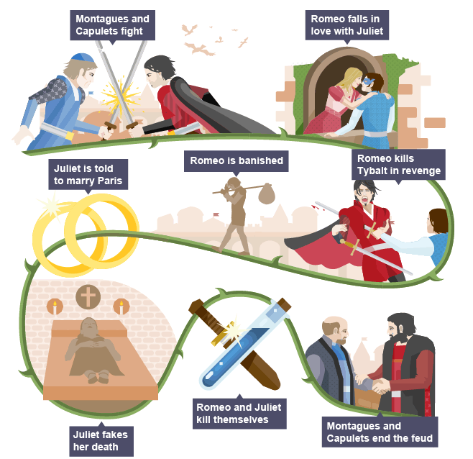

This picture represents the first meeting between Romeo and Juliet.
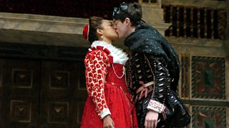
This picture shows how Mercutio is killed with Tybalt
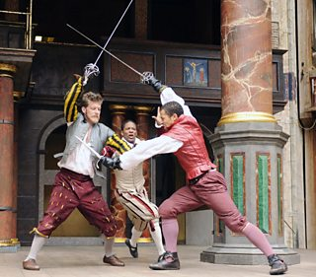
This picture shows Juliet’s fake death that ends up making them both kill themselves.
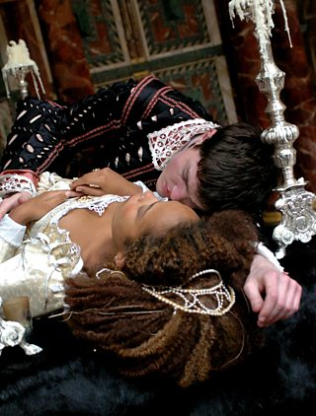
Literacy devices
Oxymoron – This is a form of speech in which two words or phrases with opposing meanings are used together intentionally for an effect. Example;
Act I Scene 1- Romeo- feather of lead
Act III Scene 2- Juliet- Speech about Tybalt's Death beautiful tyrant

Foreshadowing – This is a symbolic representation of plot developments that are to come later in the story. Example:
Act III Scene 2- When Juliet asks Romeo if he has killed himself
Act II Scene 3- Romeo confiding in Friar Lawrence

Soliloquy – The act of a character speaking to themselves to reveal their thoughts to the audience. An instance is seen when Juliet awaits the nurse;
Act III Scene 2- Juliet- Wanting Romeo
Act II, Scene 3- Friar Lawrence- Cycle of Life

Personification – this is a literary device in which an inanimate object or an idea is given human qualities. For instance, in Act III, Scene 2- Juliet giving the night a personality
Act I Scene 1- Benvolio gives the night a gender

Work Cited
William, Shakespeare. Romeo and Juliet. Strelbytskyy Multimedia, 2017.
White, R. S. "‘Star-crossed lovers’: Romeo and Juliet and romantic tragedy." Shakespeare’s cinema of love. Manchester University Press, 2016.
Guneratne, Anthony. Shakespeare, Film Studies, and the Visual Cultures of Modernity. Springer, 2016.
Luong, V. "Semantic Features of the Vietnamese Translation of Shakespeare’s Romeo and Juliet." International Journal of English Language & Translation Studies 4.2 (2016): 46-62.

